|  |  |
| --- | --- |
| Name: | Edward Eisenberger |
| ID# | 1066164 |
| Assignment 7 | |
| Date of Submission | July 8, 2019 |

Table of Contents

Overview 3

Part 1: WCF Tutorial 3

Summary 3

Results 3

FirstWCFHost, FirstWCFClient, and WCFLib 3

SecondWCF and SecondWCFClient 4

Part 2: WCF Publisher Subscriber and Client Callbacks 6

Summary 6

Results 6

# Overview

# Part 1: Clustering Algorithms in AI Handout

## Summary

## Results

# Part 2: N-D GMM Algorithm

## Summary

## Results

# Part 3: Parallelization of KMeans++, KMedoids, and GMM Algorithms

## Summary

## Results

# Part 4: N-D GMM Swarm Intelligence

## Summary

## Results

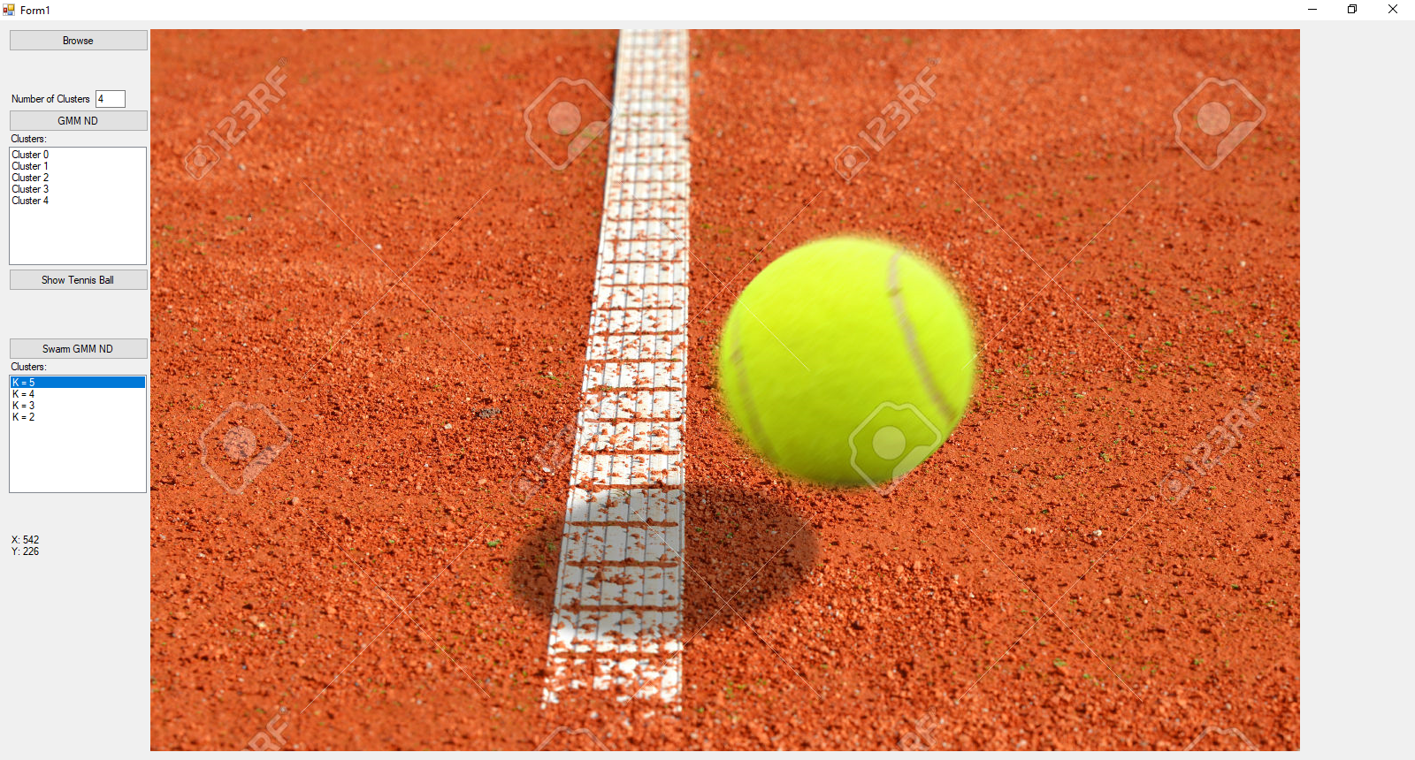

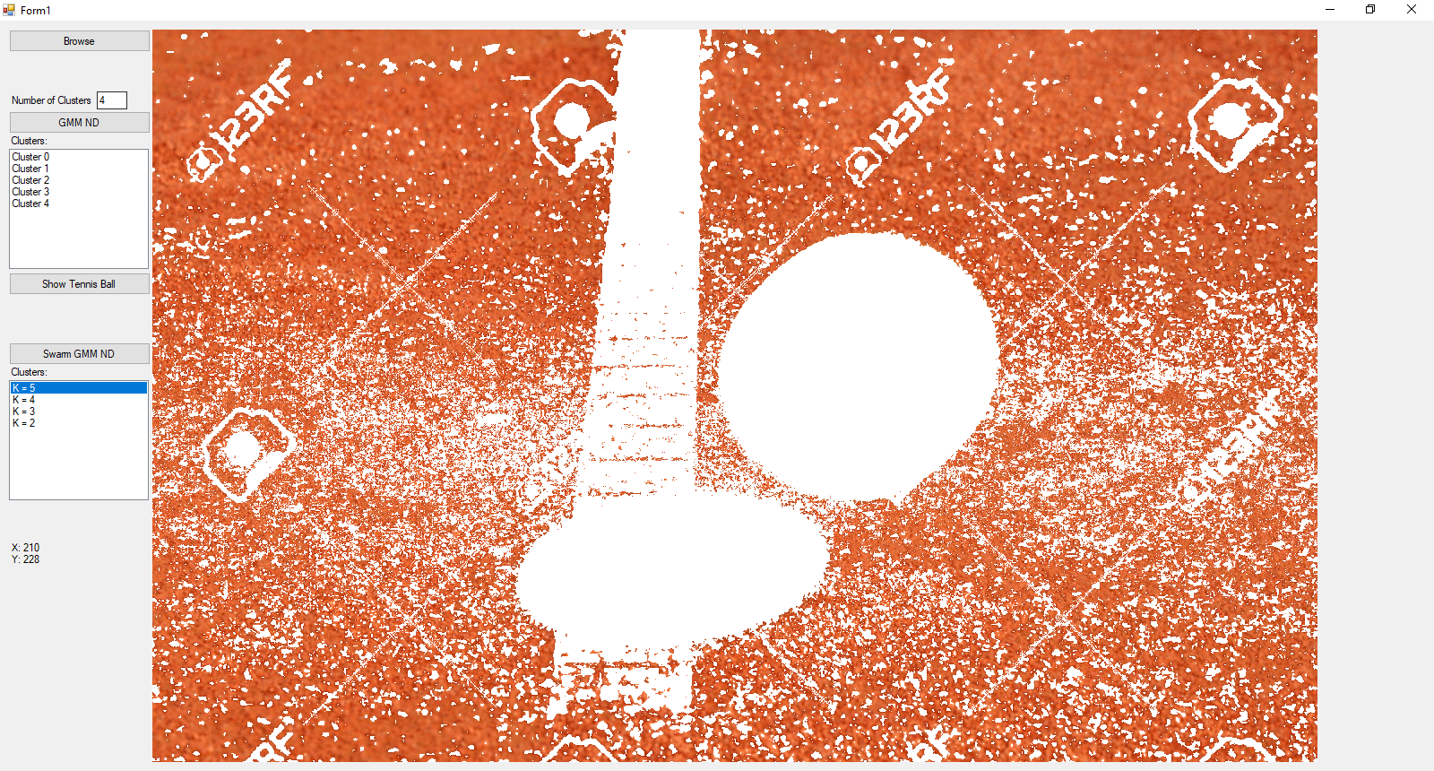

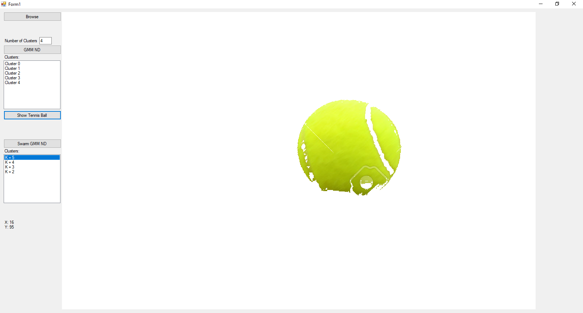

Figure - Tennis Ball K=5

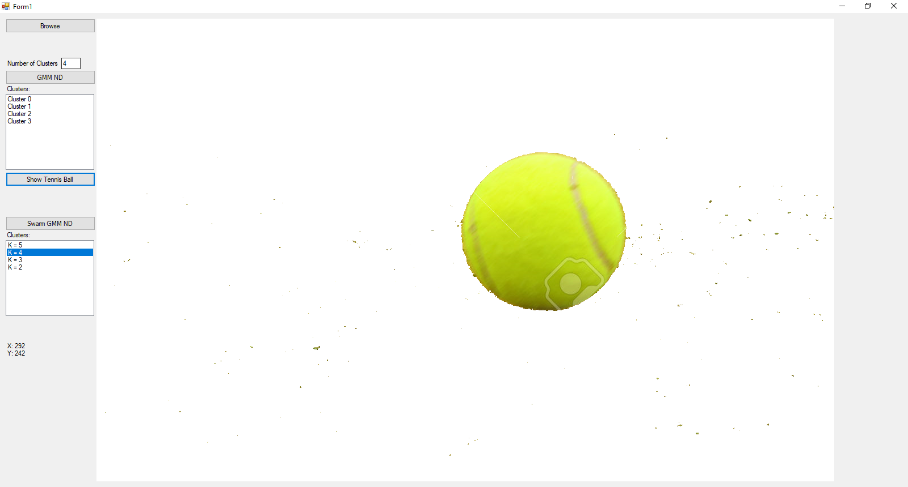

Figure - Tennis Ball K=4

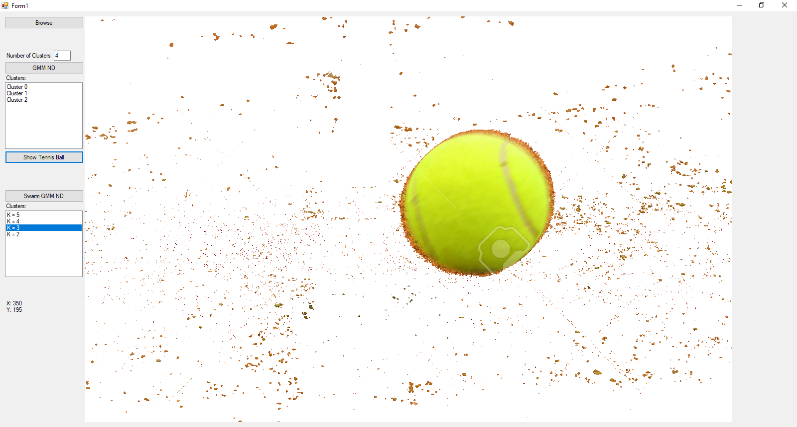

Figure - Tennis Ball K=3

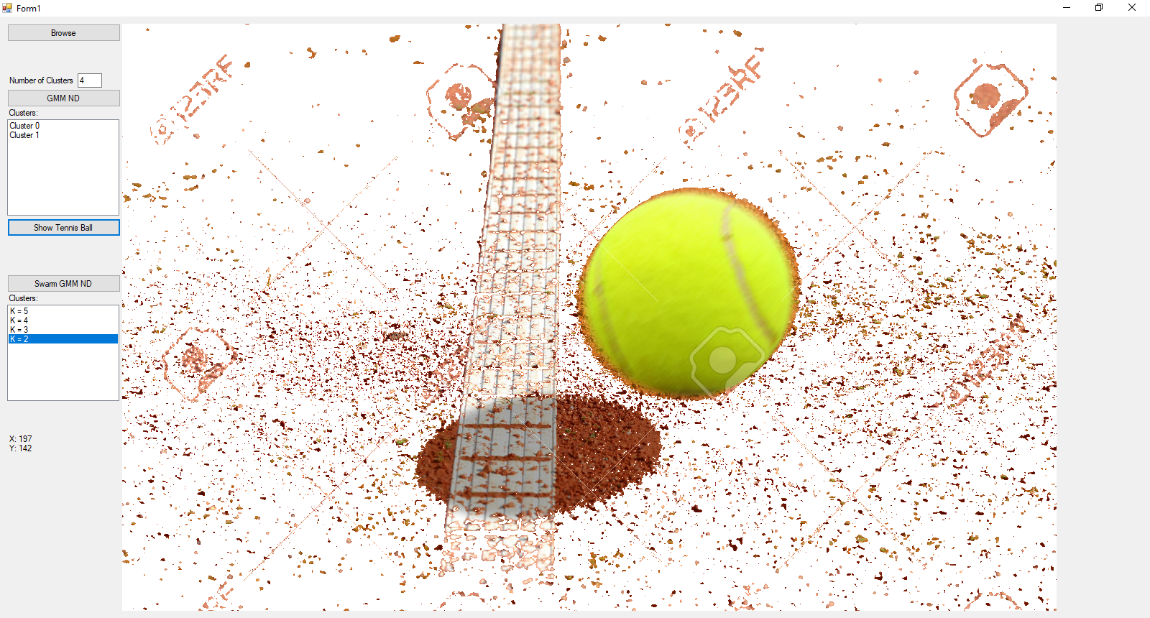

Figure - Tennis Ball K=2